# CHAPTER 3

**METHODOLOGY**

## Introduction

In this chapter, the methodology used to develop SK SP homework management system will be discussed. In the process of researching, planning, designing, developing, testing, setup, and maintaining a software product a software development methodology is used [5]. Different methodologies would have different processes and ways of implementation. In this project, the chosen methodology is scrum approach.

Scrum approach is a framework for product development where different processes and techniques can be applied to complex projects. Based on Figure 1, scrum framework consists of the Scrum Roles, the Scrum Artifacts, and the Scrum Events. The Scrum Team consists of the Product Owner, the Development Team, and the Scrum Master. An incremental and iterative development approach is made possible by scrum.

The project is broken up into several phases, each of which produces a ready-to-use product. A usable product is delivered to a customer at the end of each stage (Sprint). The scrum methodology was chosen as software development methodology of this project because of the capability to adapt to the project's changing requirements [6]. Scrum teams were required to budget their finances and plan before they start any project, which effectively uses time and financial resources.

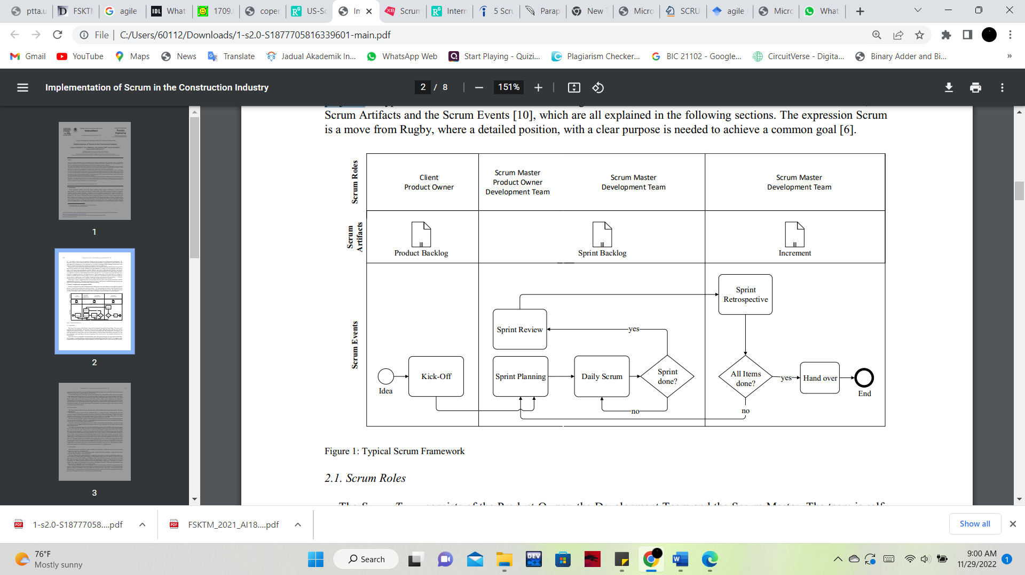

Figure 1: Scrum framework

### Pre-sprint phase

Product backlog is a list of items that need to be implemented during the development process. It is listed by priority and every item is called a user story. Each Item is split down into Tasks and represents a concise and thorough overview of what the Development Team must complete. A task is a work package that is handled by one or more Development Team members and is ideally finished in one or two days.

To record customer requirements as user stories and features, a product backlog is created. User stories are often defined according to the pattern ‘As a <User>, I want to <Have> so that <Benefit>’ [7]. The product owner, whose responsibility is to maintain visible and transparent product backlog, estimates the implementation effort after the requirements have been analyzed and assigned specific priorities. The product Backlog is subject for continuous updating since the user stories are created incrementally, and throughout the development process the priorities of the existing stories may change.

### Sprint Phase

Sprints are iterative fixed length cycles which length from 2 - 4 weeks. By having short sprint, developers can release working version of a product more frequently. They can receive customers’ feedback more often and all possible bugs and errors will be detected. While for a longer sprint duration, it will allow developers to work more thoroughly throughout the project. Each sprint follows the conventional software development process steps, which begin with requirement analysis or sprint planning from the product backlog, continue through design, and end with the delivery phase following the sprint review.

An agreement on the work that must be completed during the following sprint is made during the sprint planning meeting, which is held at the start of each sprint that includes both the development team and the product owner. The user stories are incrementally transferred from the product backlog to the sprint backlog depending on their priorities. Furthermore, the features and functionalities that should be implemented are decided. The entity of the Scrum Team defines a state of done. When a user’s stories from the Sprint Backlog are considered as done, it is removed from the Sprint Backlog and is then part of the Increment. Therefore, the Increment is the sum of all user stories considered done.

Upon the completion of the pre-sprint planning, a sprint cycle begins. During a Sprint, the team is isolated from the external distractions by the Scrum master, and the features are implemented and tested daily through a meeting that is called daily scrum. Daily scrum meetings last 15 minutes and are held to improve communication, synchronize activities, refocus the team on its common purpose that is shared by all team members, and address any issues or challenges the team may be facing. Two meetings are held at the end of each sprint. The sprint review meeting, where the sprint output is analyzed, evaluated, and discussed, and the sprint retrospective meeting, where potential future improvements are discussed.

### Project closure phase

In this phase the product owner and the team agree that the requirements met, and the desired objectives are the same in the agreement. The most recent version of the product is now prepared for distribution and release.

## System Development Workflow

There are total of three phases from the scrum model. As shown in Table 3.1, each phase has its own assignment and output that need to produce during the entire project development. Besides that, the output had been completed within the specific days that have been given.

## Chapter Summary

In this chapter, the methodology used to develop SK SP Homework Management System is introduced. Agile model is used to develop the system as it provides iterative development processes. Also, all the phases conducted in agile model is discussed in a detailed way.

Reference

Despa, M. L. (2014). Comparative study on software development methodologies. *Database Systems Journal*, *5*(3), 37-56.

Balaji, S., & Murugaiyan, M. S. (2012). Waterfall vs. V-Model vs. Agile: A comparative study on SDLC. *International Journal of Information Technology and Business Management*, *2*(1), 26-30.

Al-Saqqa, S., Sawalha, S., & AbdelNabi, H. (2020). Agile Software Development: Methodologies and Trends. *International Journal of Interactive Mobile Technologies*, *14*(11).